Simple Room Design
With the Room Planner, you’ll never make a design mistake again. Created by acclaimed interior designers to simplify the redecorating process, this planning tool incorporates elements of color, dimension, and style to guide your project. It includes a furniture location guide; room grid; drawing tools; and miniature furniture, rugs, accessories, and color swatches that match our large in-store selection. Here’s how to use the planner to create the room of your dreams!

Get started
Take a look at how your home is decorated and note the things you like and dislike. Pay special attention to the color scheme and to how each room "feels" to you. Is it inviting? Does it feel comfortable? Does it relax you or does it invigorate you?
Focus on the room(s) you would most like to change. Brainstorm all the things you would change in that room if you could. Don't give a thought to any financial considerations; just let your imagination go wild! It might be helpful to write down all the negatives and positives. You don't need to come up with solutions all at once. Just be clear on what you like and what you hate about that room.
Visit our showroom and purchase a Room Planner. While you're there, take a look around and see what really appeals to you. Sometimes entire rooms are designed around just one or two special pieces, so don't be afraid to fall in love with something that doesn't seem to fit into your overall scheme. Go with what you love, and the rest will fall into place.

Get to work
Take your Room Planner home and get to work! Adjust the planner so that it models the room dimensions. Don't forget to place the windows and doors. Arrange the furniture placeholders to mirror how your room is currently set up. Add the current colors, too.
This is where the fun begins! Start changing things around a bit. Move the furniture, add different colors, and watch the room come together! Here's where you can tell if that rich red rug you saw in the showroom enhances or overwhelms your room. What about that overstuffed chair that caught your eye? Place a furniture or accessory shape, and then color it. Does it look great or is it too jarring? Change the color... does that help? Don't forget about the walls. Try different colors to see the effect on the room overall.

Take a break
When you're sure you have the right look and feel, take a break. Put the planner away and sleep on your design for a day or two. Then review it again. Does it still look perfect, or is something not quite right? You might need to live with the new plan for a few days, especially if you’ve made big changes. When everything feels just right to you, you're ready for the next big step!

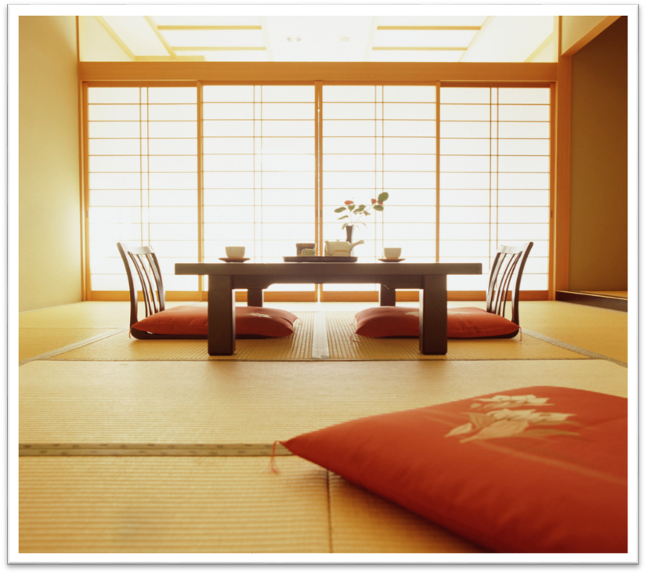
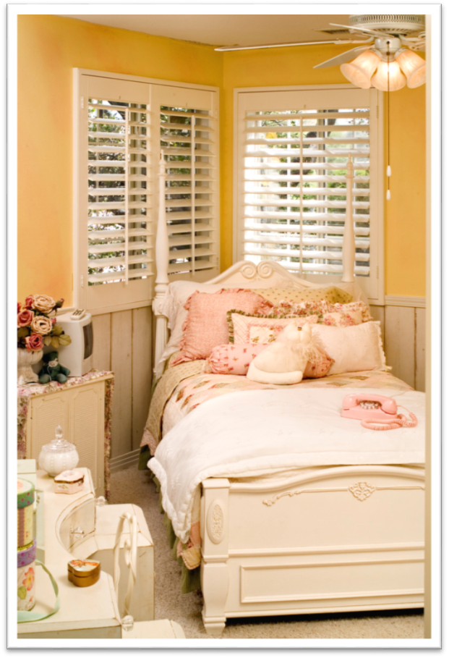

Wrap it up
Come back to the store. Look again at the pieces you liked during your last visit and see if you still love them. If you're not quite sure, go back to your planner for a little more tweaking. If you are sure, take a look around the store one more time to see if anything else catches your eye. Then make your purchases. You're almost there!
NOTE: If you decided to paint your room, do that before your new pieces are delivered. You'll want to start enjoying your new room as soon as your purchases arrive.
After a few weeks, ask yourself whether the room is as great as you thought it would be. Does it achieve the look and feel you were after? You have 30 days to fall in love with our furniture and accessories, so if you are disappointed in any way, you can return undamaged pieces for just a nominal restocking charge.
If you're not sure you made the right choices and don't know which way to turn, arrange to meet with one of our designers. This free service is available to all our customers. Sometimes talking over your plans or obstacles with a professional can really help get you back on track.
Success! Your room is everything you hoped for. Now what about your bedroom? Maybe a new linen chest or perhaps new window treatments? The Room Planner can be used countless times for any room in the house. And if you're eyeing your patio or deck as your next makeover project, you’ll want to check out the Outdoor Room Planner, too.


To order the Room Planner for just $39.99 plus shipping and handling, visit our website at www.wideworldimporters.com or call us at 925-555-0167. The Outdoor Room Planner retails for $29.99 plus shipping and handling. Both planners are also available in our stores, so be sure to ask about them the next time you visit. We accept all major credit cards.


